February 19th, 2006
Hi
KUNG HEI FAT CHOI
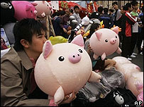
Chinese New Year is today. The four-day public holiday began yesterday. This is the year of the pig and is supposed to be especially auspicious as it is a ‘golden’ pig year, which comes around only once every 60 years. In Hong Kong, golden pig toys are on sale everywhere (picture).
Rather eventful in Hong Kong this past week. The two candidates for the Chief Executive election registered their intent to stand for election. Of the 800 potential nominations, Donald Tsang got 642 and his pro-democratic rival 132. So a few did not nominate anyone. The election will be held on March 25th.
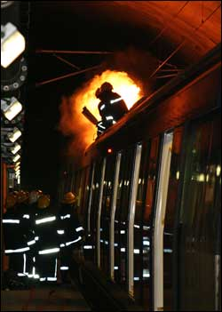
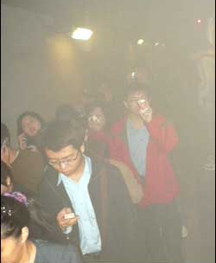
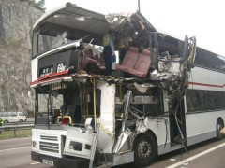
There was a fire on a KCR train in the Tai Lam (train) tunnel the other morning. It is believed to have been caused by burning oil from a transformer on the roof of one carriage (picture). The train stopped in the tunnel and the 650 or so passengers evacuated through thick smoke (picture) and headed towards Tsuen Wan, which took about 30 minutes. No fatalities. Then yesterday there was another KMB bus accident. A bus, heading from this way to Kowloon was near the Tai Lam (road) tunnel when it failed to overtake a container truck properly and slammed into the corner of the truck (picture). Some passengers tossed out the windows while others were trapped under seats. At least one fatality.

Applied for my new ID card the other day. Unlike all of you, rather than a temporary ID card, they returned my existing card, which I then hand in when getting the new card.
Started exercise again. Skipping rather difficult for a few days even though only one week off. Doing just 15 minutes skipping each time, as I also want to do other kinds of exercise. Also began skipping bare feet. Found that this helps to reduce the amount of tripping. The run yesterday felt much better with times for the first two legs almost back to normal. Ended with a new, but not interesting, route. Also, I did not need to sleep in the afternoon.
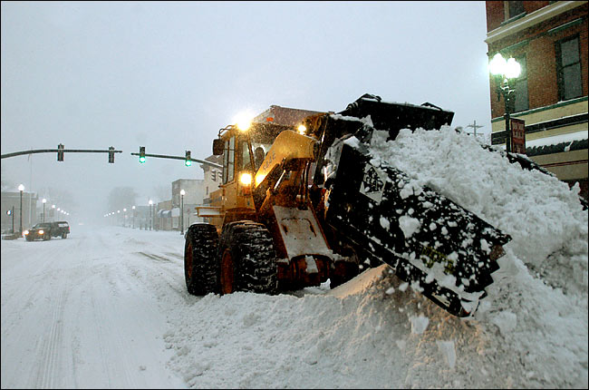
Winter seems to have hit the US East. All-time record snowfalls in New York, up to 12 feet (picture). In Tokyo it is just the opposite; there has been no snow at all this winter – too warm!
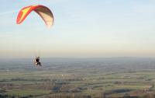
Did you here about the dramatic sky diving accidents this past week in Australia and New Zealand? In Australia, the world paragliding championships are to be held soon. A German woman was swept to an altitude of more than 32,000 feet, higher than Mount Everest, by powerful updrafts from storm clouds that formed suddenly. She lost consciousness for about a-half hour while her glider flew on uncontrolled, but woke up and was able to land safely. She survived the ordeal with just some frostbite to her face. She was very lucky as at that altitude, there is very little air and temperatures can be -50⁰C. Unfortunately, a Chinese competitor caught in the same updraft was killed; his body was found 47 miles from where he took off.
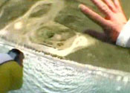
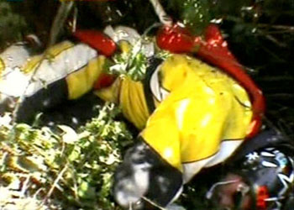
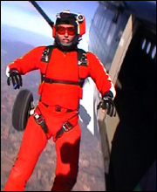
Then there was the case of the British parachutist at Lake Taupo in NZ who survived a 5000-metre fall after both his 'chutes failed to open (properly). His main parachute collapsed and he found himself heading for the ground at 120 mph, which then caused problems for the reserve parachute. All this was recorded on his helmet video and that of his jumping partner. He crashed into dense bush as was found unconscious in a blackberry bush, alive and with just a punctured lung and broken ankle. The pictures show the guy himself, spirally out of control and lying in the blackberry bush.

The third round of the Super 14 took place this past weekend. The Crusaders lost again, this time to a South African team. They have won only one game and are obviously suffering from all the All Blacks who are missing from the team.
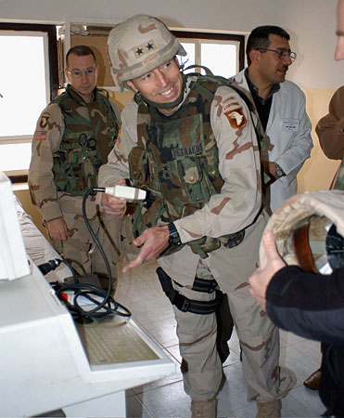
Heard on the news this morning that the US Senate (upper house of Congress) rejected the non-binding resolution criticising Bush for increasing number of troops in Iraq that had been previously passed by the House of Representatives (lower house). I am happy about that. Now that the US is mired in Iraq, they have to finish the job properly and that requires more troops, and more money to support them. The start of counter-insurgency is long overdue. Moreover, the commander, General Petraeus, seems to know something about it. He was trying to do this when he was commander of the 101st Airborne Division, but got no support from Rumsfeld and others.
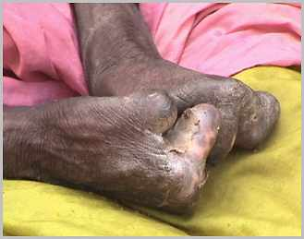

Heard a little snippet on the news that although leprosy has been almost eliminated in the most parts of the world, it is actually increasing in Indonesia.

That’s about it for this time.

Cheers.

